ASP.NET Core 8.0 Web API

6. Web API Hands on
1. Aim
To integrate Apache Kafka with C# and develop a simple chat application using Kafka Producer and Consumer, followed by a C# Windows Forms application that consumes Kafka messages.
2. Software / Tools Required
- Java (JDK)
- Apache Kafka 3.9.1 (Scala 2.13 binary)
- Visual Studio
- C# / .NET
- Confluent.Kafka NuGet package
- Command Prompt
3. Kafka Setup
Kafka was downloaded, extracted, and placed at:
C:\kafka\kafka_2.13-3.9.1
ZooKeeper was started using:
cd /d C:\kafka\kafka_2.13-3.9.1
bin\windows\zookeeper-server-start.bat config\zookeeper.properties
Kafka Server was started using:
cd /d C:\kafka\kafka_2.13-3.9.1
bin\windows\kafka-server-start.bat config\server.properties
Kafka Server successfully started and listened on port 9092.
4. Creating Kafka Topic
The topic chat-topic was created using:
bin\windows\kafka-topics.bat --create --topic chat-topic --bootstrap-server localhost:9092 --partitions 1 --replication-factor 1
The topic was verified using:
bin\windows\kafka-topics.bat --list --bootstrap-server localhost:9092
5. C# Kafka Producer
A C# Console Application named KafkaProducer was created. The Confluent.Kafka package was installed from the Visual Studio Package Manager Console:
Install-Package Confluent.Kafka
Producer code:
using Confluent.Kafka;
var config = new ProducerConfig
{
BootstrapServers = "localhost:9092"
};
using var producer = new ProducerBuilder<Null, string>(config).Build();
Console.WriteLine("Kafka Chat Producer");
Console.WriteLine("Type a message and press Enter. Type 'exit' to stop.");
while (true)
{
Console.Write("You: ");
string? message = Console.ReadLine();
if (message == "exit")
break;
await producer.ProduceAsync(
"chat-topic",
new Message<Null, string>
{
Value = message
});
Console.WriteLine("Message sent!");
}
6. C# Kafka Consumer
A second C# Console Application named KafkaConsumer was created with the same Confluent.Kafka package.
Consumer code:
using Confluent.Kafka;
var config = new ConsumerConfig
{
BootstrapServers = "localhost:9092",
GroupId = "chat-consumer-group",
AutoOffsetReset = AutoOffsetReset.Earliest
};
using var consumer = new ConsumerBuilder<Ignore, string>(config).Build();
consumer.Subscribe("chat-topic");
Console.WriteLine("Kafka Chat Consumer");
Console.WriteLine("Waiting for messages...");
try
{
while (true)
{
var result = consumer.Consume();
Console.WriteLine($"Received: {result.Message.Value}");
}
}
catch (OperationCanceledException)
{
consumer.Close();
}
7. Testing the Chat Application
The Kafka Consumer was started first, followed by the Kafka Producer. Messages entered in the Producer were successfully delivered through chat-topic and displayed by the Consumer.
Component | Action | Result
Producer | Sent message to chat-topic | Message sent successfully
Kafka | Transferred message through chat-topic | Message delivered
Consumer | Consumed message from chat-topic | Message displayed successfully

8. C# Windows Forms Kafka Consumer
A Windows Forms application named KafkaWindowsConsumer was created. The form contains a Label, a multiline read-only TextBox named txtMessages, and a Button named btnStart. The Confluent.Kafka package was installed.
The unused label Click event was removed from Form1.Designer.cs to resolve the Windows Forms Designer error.
Main Windows Forms consumer code:
using Confluent.Kafka;
namespace KafkaWindowsConsumer
{
public partial class Form1 : Form
{
private CancellationTokenSource cancellationTokenSource =
new CancellationTokenSource();
public Form1()
{
InitializeComponent();
}
private async void btnStart_Click(object sender, EventArgs e)
{
btnStart.Enabled = false;
txtMessages.AppendText("Consumer started...\r\n");
var config = new ConsumerConfig
{
BootstrapServers = "localhost:9092",
GroupId = "windows-client-" + Guid.NewGuid(),
AutoOffsetReset = AutoOffsetReset.Latest
};
await Task.Run(() =>
{
using var consumer =
new ConsumerBuilder<Ignore, string>(config).Build();
consumer.Subscribe("chat-topic");
try
{
while (!cancellationTokenSource.Token.IsCancellationRequested)
{
var result = consumer.Consume(
cancellationTokenSource.Token);
this.Invoke(new Action(() =>
{
txtMessages.AppendText(
"Received: " +
result.Message.Value +
Environment.NewLine);
}));
}
}
catch (OperationCanceledException)
{
consumer.Close();
}
});
}
protected override void OnFormClosing(FormClosingEventArgs e)
{
cancellationTokenSource.Cancel();
base.OnFormClosing(e);
}
}
}

9. Screenshots
Screenshot 1: ZooKeeper running
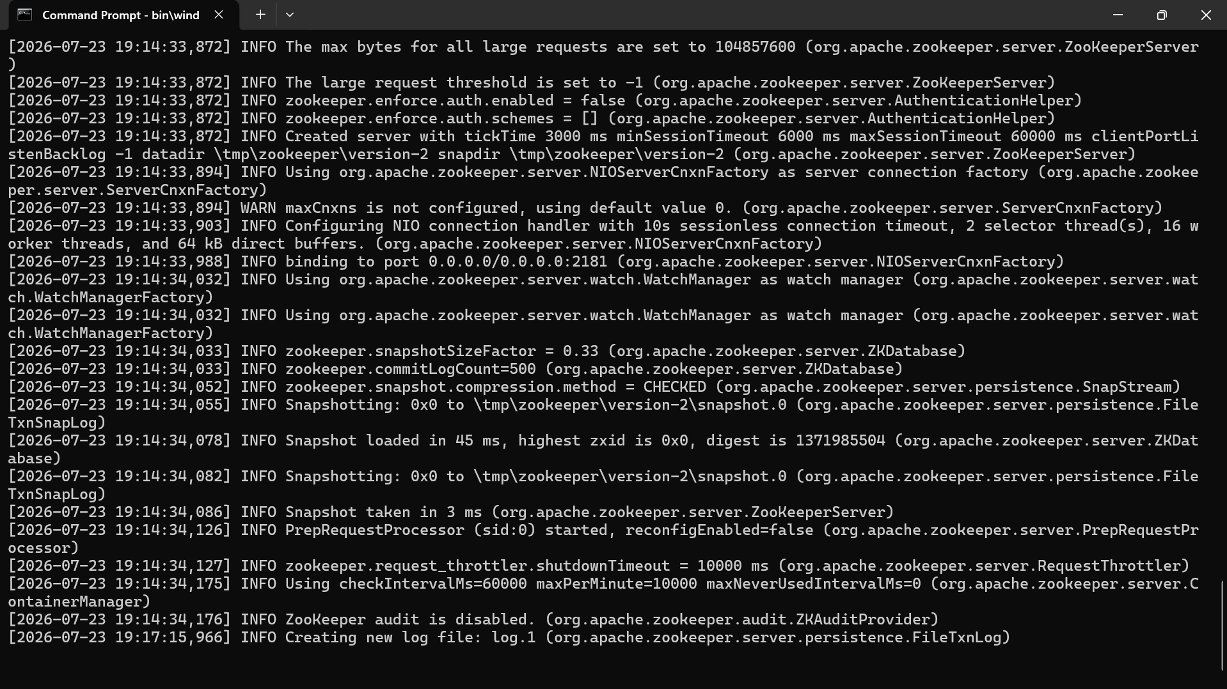
Screenshot 2: Ka fka Server running 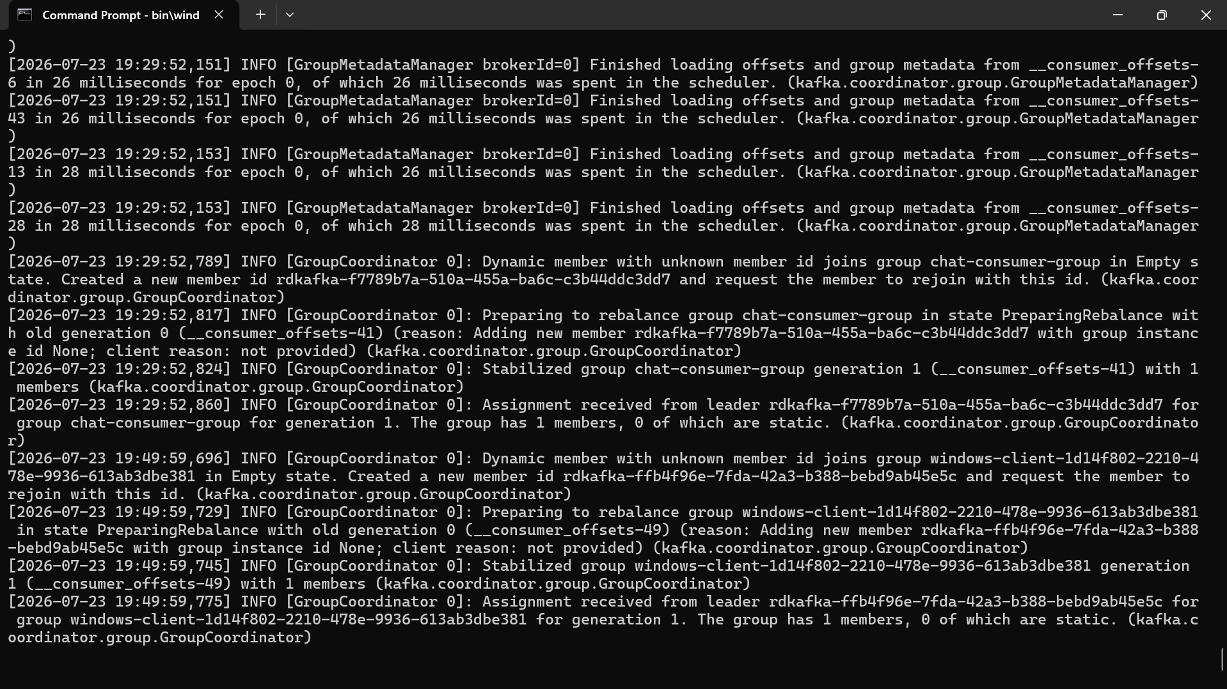

Screenshot 3: chat-topic created and verified
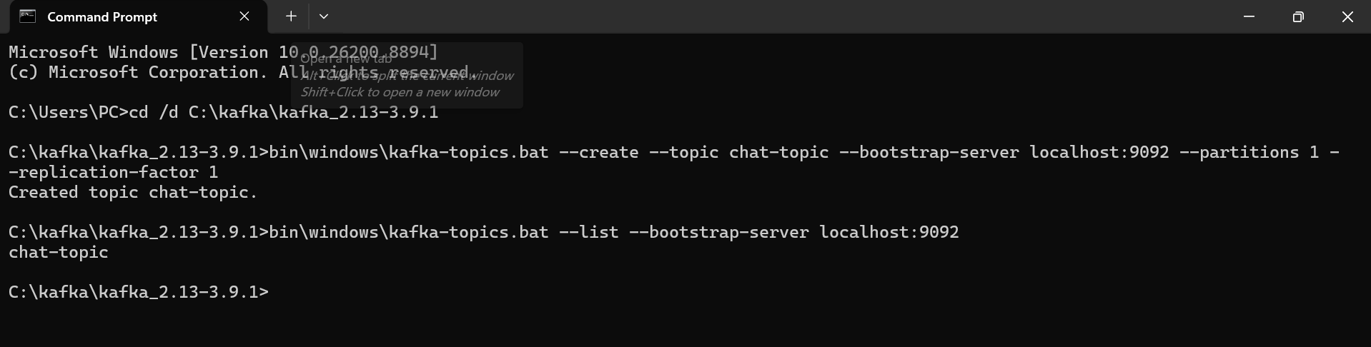
Screenshot 4: Kafka Producer sending a message
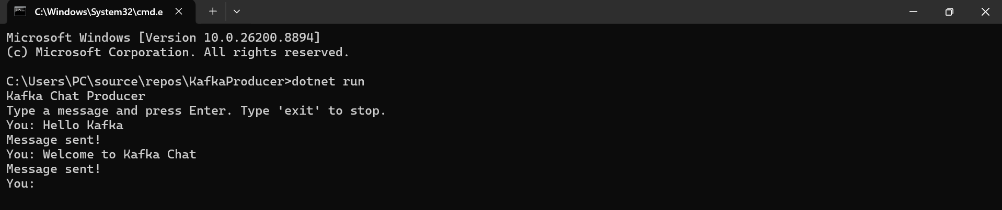
Screenshot 5: Kafka Console Consumer receiving a message
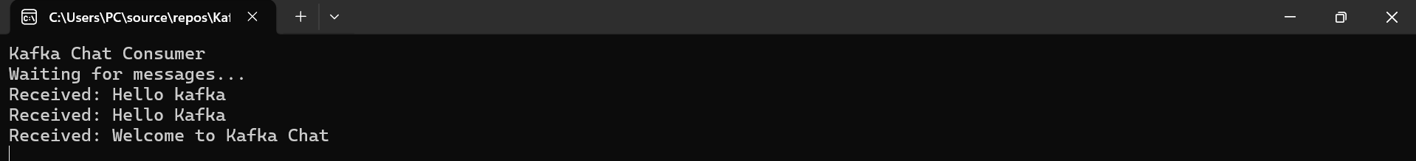

Screenshot 6: Windows Forms Kafka Consumer receiving a message
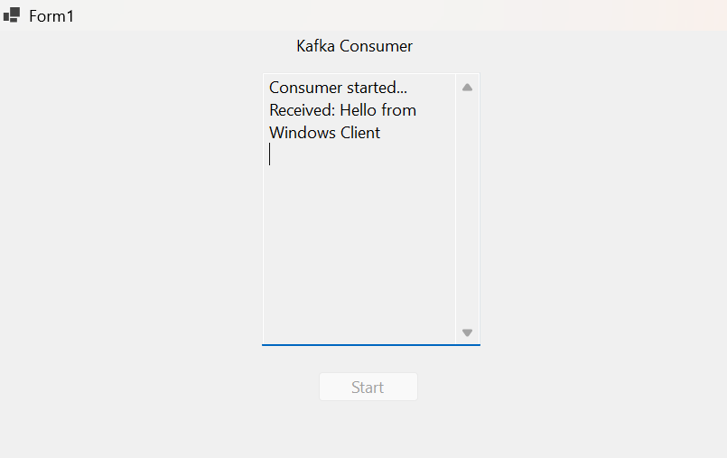
10. Result
The Kafka integration with C# was successfully completed. A Kafka-based chat application was developed using a C# Producer and Consumer. Messages were successfully sent through chat-topic and consumed in the console. A C# Windows Forms Kafka Consumer was also implemented and successfully displayed messages received from Kafka.

